**-Practical 2**

**Aim: Test any 2 websites using Selenium IDE & perform actions - Verify title, Assert text, Store text**

**Steps: For testing Website 1 :** [**https://paytm.com/**](https://paytm.com/)

1. Open Selenium IDE > Create New Project > Enter the URL <https://paytm.com/>> Start Recording
2. It will direct you to the Webpage > Slide towards Bus Tickets > Fill the details
3. Right Click Near Title (paytm) > In the Dropbox, Click on Selenium IDE > Verify > Title > Title is verified
4. Right Click Near Travels (Intercity Smart Bus) > In the Dropbox, Click on Selenium IDE > Assert > Text > Text is verified
5. Right Click Near Fare > In the Dropbox, Click on Selenium IDE > Store > Text > Text is Stored
6. It will Return Back to SELENIUM IDE > Add variable **fare** > OK
7. In the Command Section > Add Command “echo” > Add Value **${fare**}
8. Stop Recording > Name the Testcase (1sttestcase) > Run the Test Case

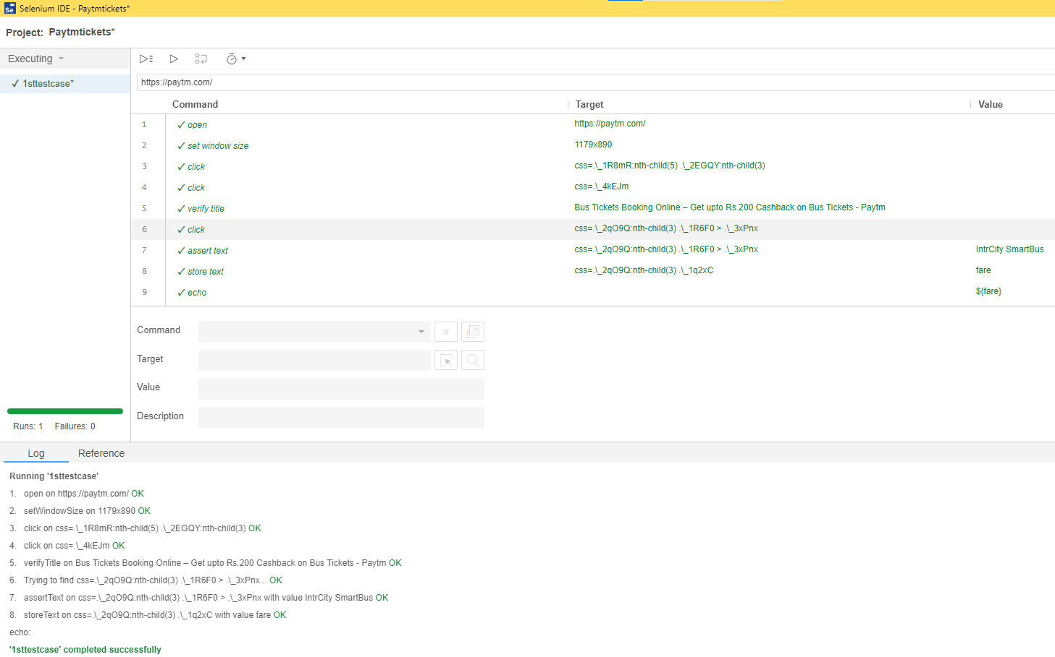

**Steps: For testing Website 2 :** [**https://www.ixigo.com/**](https://www.ixigo.com/)

1. Open Selenium IDE > Create New Project > Enter the URL [**https://www.ixigo.com/**](https://www.ixigo.com/)> Start Recording
2. It will direct you to the Webpage > Slide towards Flight Tickets > Fill the details
3. Right Click Near Title (ixigo) > In the Dropbox, Click on Selenium IDE > Verify > Title > Title is verified
4. Right Click Near Travels (Akasa Air) > In the Dropbox, Click on Selenium IDE > Assert > Text > Text is verified
5. Right Click Near Price > In the Dropbox, Click on Selenium IDE > Store > Text > Text is Stored
6. It will Return Back to SELENIUM IDE > Add variable **price**> OK
7. In the Command Section > Add Command “echo” > Add Value **${price**}
8. Stop Recording > Name the Testcase (2ndtest) > Run the Test Case

